✓ | Action | Details
OPEN ROOM
☐ | Collect keys | Go to “MEDICAL ROOM” and open the black lockbox using code 613. Take red room key labelled A3, and the yellow room key labelled S3. Unlock testing room A3.
ROOM CHECKS
☐ | Turn light on
☐ | Draw blinds
☐ | Check headphones are plugged in | Place the headphones next to stimulus PC so that they will be clearly visible to the participant
☐ | Arrange chairs | Make sure the stationary chair (not office chair) is positioned in front of stimulus PC
☐ | ECG electrodes available | Ensure you have at least one sheet of the blue round ECG electrodes.  If more electrodes are needed, collect a new pack from room S3 (down the corridor to the left). Room keys can be found in the black lockbox (code 613).
☐ | EDA electrodes available | Ensure you have at least one sheet of the white rectangular EDA electrodes.  If more electrodes are needed, collect a new pack from room S3 (down the corridor to the left). Room keys can be found in the black lockbox (code 613).
☐ | Spectra Gel available | Blue Spectra Gel is stored in room S3 (down the corridor to the left). Room keys can be found in the black lockbox (code 613).
☐ | Isotonic Gel available | White Isotonic Gel is stored in room S3 (down the corridor to the left). Room keys can be found in the black lockbox (code 613).
☐ | Medical tape available | Medical tape is stored in room S3 (down the corridor to the left). Room keys can be found in the black lockbox (code 613).
☐ | Check External Hard-Drive | Collect the external hard-drive from room S3
☐ | Prepare ECG pack | Unplug ECG box from charger and connect leads (use the lead that has three cables, red, white and black)
☐ | Prepare EDA pack | Unplug EDA box from charger and connect leads (use the lead that has two cables, red and black)
☐ | Check computer monitor position | Monitor must be inside the taped lines
☐ | Remove Rubbish | Move anything that shouldn’t be in the room e.g. pieces of paper, rubbish etc.
STIMULUS PC
☐ | Turn on Stimulus PC
☐ | Log in | Log in to Irise Lab – password: irise2026
☐ | Set volume to 30
☐ | Open PsychoPy | Open Psychopy v2026.  Go to the navigation bar at the top of the GUI, click “Window” -> “Show Builder”  In the new window, go to the navigation bar at the top of the GUI, click “File” -> “Open” -> navigate to:  "C:\Users\irise_lab\Documents\Biosignals2\Experiment\Biosignals2_Psychopy_PNG2AVI.psyexp"
☐ | Open VS Code | Open Visual Studio Code using the blue shortcut on the Desktop
☐ | Open terminal and run command | Go to the terminal box at the bottom of the Visual Studio Code Window. You can either press the ^ arrow key on the keyboard until you find the command written below, or you can manually type it in:  python -m http.server 8000  Press “Enter”  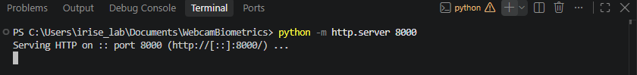
☐ | Open second terminal and run command | (Press the + sign to open a second window - see screenshot above).  You can either press the ^ arrow key on the keyboard until you find the command written below, or you can manually type it in:  & "C:\Program Files\Google\Chrome\Application\chrome.exe" --disable-background-timer-throttling --disable-renderer-backgrounding --disable-backgrounding-occluded-windows  Press “Enter”  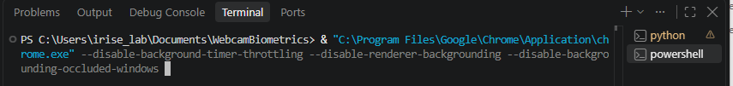
☐ | Set up Chrome | Chrome should open automatically.  If the window that opens doesn’t show the Google search bar with bookmarks below, open New Tab (Not a new window).  Click the blue “webcam-biometrics” icon below the google search bar  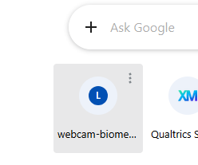
☐ | Check Logitech camera alignment | Sit down in the participant chair and make sure it is positioned in the taped lines.  Use the “Camera for this page:” drop down to select the Logitech Camera  Check that you can see your face clearly, readjust camera as needed.
☐ | Check Microsoft camera alignment | Sit down in the participant chair, and make sure it is positioned in the taped lines.  Use the “Camera for this page:” drop down to select the Microsoft LifeCam HD-3000  Check that you can see your face clearly, readjust camera as needed.
☐ | Set webcam biometrics | Set the webcam bio metrics camera to Microsoft LifeCam HD-3000  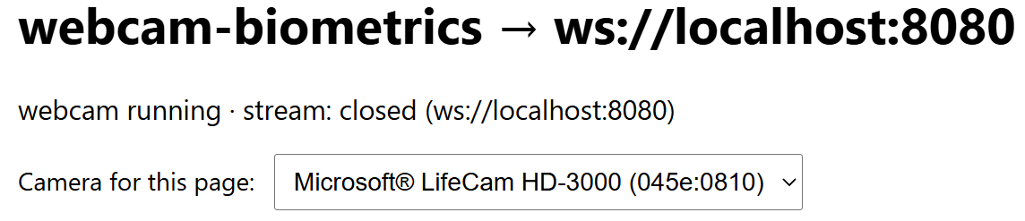
☐ | Open consent form | New Chrome window → Bookmarks → (first) Qualtrics Survey | ...  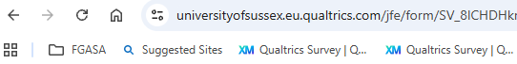  You should see “Welcome” in big blue writing
☐ | Open demographics form | New Chrome tab → Bookmarks → (second) Qualtrics Survey | ...  You should see a textbox where participants are instructed to generate their participant id
BIOPAC PC
☐ | Turn on BIOPAC PC
☐ | Turn on MP36 | Switch on the MP160 unit using the button at the back
☐ | Open AcqKnowledge | Existing Graph File → "C:\Users\iriselab\Documents\Biosignals2\Template_biosignals2.gtl”
PARTICIPANT ARRIVAL
☐ | Show participant to the testing room
☐ | Ask if they need to use the toilet
☐ | Make small talk | E.g., “Did you find the room okay?”
☐ | Show participant where to sit
☐ | Introduce the consent form | “Before we begin the study, we will ask you to read through the information sheet and sign the consent form. Let me know when you are done or if you have any questions. I’ll be right outside.”
☐ | Leave the participant to complete consent
☐ | Check consent has been completed | Ensure Qualtrics has reached the end of the survey
☐ | Explain the experiment | Briefly explain what the participant is about to do.  “We’ll start by setting up the physiology recording equipment, which we’ll do in a moment. Once that’s set up, I’ll ask you to complete some questionnaires on this computer, which should take about 10 minutes. After that, you’ll watch a series of videos and answer some questions about them on the computer. That part should take around 20 minutes. Once you’ve finished that, the experiment is complete. Do you have any questions before we get started?”
ECG SENSOR PLACEMENT
☐ | Explain procedure | “We will begin by setting up some equipment that will measure signals from your heart. I’ll show you how to do this, then I will leave the room to give you some privacy and you will connect everything up yourself.  The end goal is to have 3 electrodes placed on your torso, with each electrode connected to the appropriate colour wire.”
☐ | Fit BioNomadix belt | Ask the participant to put the belt around their waist so that it is comfortable
☐ | Have ECG placement diagram ready | Use the diagram to show the participant where each electrode should be placed
☐ | Inspect ECG electrodes | Peel the backing off each electrode patch and check that it is not dry
☐ | Add gel if required | If an electrode is dry, add a small drop of Spectra Gel (blue bottle) to the patch
☐ | Explain electrode placement | Ask the participant to place the sticky electrodes in the correct locations using the mirror while you are outside the room
☐ | Explain ECG lead connection | Ask the participant to connect the correct crocodile clip to each ECG electrode while you are outside the room
☐ | Leave the room | Allow the participant privacy to place the ECG electrodes and connect the clips
☐ | Turn on ECG BioNomadix unit | Show participant how to turn on the BioNomadix unit, and have them switch it on.
EDA SENSOR PLACEMENT
☐ | Explain procedure | “Now we will set up the equipment to measure the sweat levels in your skin. I will attach the electrodes and wires for you this time”
☐ | Inspect EDA electrodes | Peel the backing off each electrode patch and check that it is not dry
☐ | Add isotonic gel if required | If dry, add isotonic gel (white bottle) and work it into the electrode patch using a finger or syringe
☐ | Position participant’s hand | Ask the participant to hold their left hand palm-up
☐ | Place EDA electrodes | Place the electrodes on the top segment of the index and middle finger
☐ | Secure with tape | Secure the electrodes in place with medical tape in the drawer. Don’t make this too tight, just enough to ensure they don’t fall off.
☐ | Attach EDA BioNomadix unit | Place the BioNomadix unit on the participants wrist (box on the top of their arm)
☐ | Connect lead wires | Secure the lead wires to the electrodes (see diagram in testing room)
☐ | Check lead placement | Red lead → index finger; Black lead → middle finger
☐ | Turn on EDA BioNomadix unit
START RECORDING & CHECK SIGNALS
☐ | Start recording | Press Start (green circle) in AcqKnowledge
☐ | Check ECG signal | Confirm that the ECG signal is being recorded correctly (see quality check section of this document)
☐ | Check EDA signal | Confirm that the EDA signal is being recorded correctly (see quality check section of this document). Note – have participant do the “sniff test”
☐ | Show participant movement artefacts | Show participants the EDA and ECG signal. Ask them to squirm around and tap/move their fingers to show them the effect of movement on data quality. Use this as an opportunity to ask them to stay as still as possible when they are doing the experimental procedure (not the questionnaires)
QUESTIONNAIRES & EXPERIMENT
☐ | Open Demographics Questionnaire | Go to the Demographics Questionnaire tab. Tell the participant: “We’re now going to ask you to answer some questions about yourself. This should take around 10 minutes. I’ll be just outside - let me know when you’re finished and I’ll come back in, and then we’ll move on to the experiment.”
☐ | Check questionnaire is complete | When the participant tells you they have finished, check that Qualtrics has reached the end of the survey.
☐ | Check camera placement | Navigate to WebcamBiometrics chrome tab. Double check that the participant is clearly visible in the frame of both cameras. Adjust as needed.
☐ | Set Webcam-biometrics Camera | Set the webcam bio metrics camera to Microsoft LifeCam HD-3000
☐ | Start PsychoPy experiment | Return to PsychoPy and press “Run”(Green Circle) at the top of the GUI.
☐ | Enter participant ID | Instruct the participant to enter the last letter of their surname + last 4 digits of their phone number as their participant ID.
☐ | Hand Placement Instructions | Ask participants to place their hand palm-up on the mouse pad. Instruct them to keep their hand and fingers as still as possible and to avoid tapping their fingers, as movement can introduce noise into the skin conductance recording. Participants should also be asked to minimise movement of their upper body, as this can introduce artefacts into the ECG recording.
☐ | Give participant headphones | Check that the headphones are positioned comfortably.
☐ | Leave participant to complete experiment | Tell the participant: “I’ll be just outside. Let me know when you’re finished or if you need anything.” Leave the room and close the door.
END OF EXPERIMENT
☐ | Stop Acqknowledge recording | Go to the Acqknowledge PC and press “Stop” in the top lefthand corner of the screen to stop recoding. Press “Save” -> name the file “temp”
☐ | Thank participant | Tell the participant that the study is complete and thank them for their time.
☐ | Remove physiology equipment | Ask the participant to unclip the ECG/EDA leads and remove the electrode patches. Show them where to dispose of the used electrodes.
☐ | Provide tissues | Let the participant know that tissues are available to wipe away any excess gel.
☐ | Debrief participant | Give the participant the debrief document and allow them time to read it and ask any questions.
☐ | Show participant out | Show the participant to the exit and thank them again for taking part. Encourage them to tell others about the study if appropriate.
DATA SAVING
☐ | Check participant ID | Before saving or moving any files, confirm the participant ID from the PsychoPy experiment. Use this same ID for all participant data files.
☐ | Save webcam data | Copy the webcam data to the external hard drive. Confirm that the files have copied successfully before deleting the originals from the Stimulus PC.
☐ | Save AcqKnowledge data | Save the AcqKnowledge recording using the participant ID as the filename in: "C:\Users\irise_lab\Box\Project_Biosignals_study_2\3_Data\raw_physiology".
☐ | Create Ledalab file | In AcqKnowledge, select Edit → Remove Waveform and remove all channels except the EDA data.
☐ | Export Ledalab file | Select File → Export → Export Other and save as a .mat file.
☐ | Save Ledalab file | Save to “C:\Users\irise_lab\Box\Project_Biosignals_study_2\3_Data\ledalab\input” using only the participant ID as the filename.
☐ | Save PsychoPy data | Save/copy the participant’s PsychoPy data files to “C:\Users\irise_lab\Box\Project_Biosignals_study_2\3_Data\psychopy”.
☐ | Final data check | Confirm that the webcam, AcqKnowledge, Ledalab and PsychoPy files have all been saved successfully and use the correct participant ID.

